JECRC
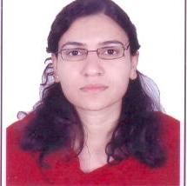sport
size photograph
JAIPUR

INDIVIDUAL FACULTY DATA SHEET
Name of the faculty member | : | Ms. Shivam Upadhyay
Present Designation | : | Assistant Professor
Email Id : Shivam.ece@jecrc.ac.in

Contact Details : +91-9462257514

I. Particulars of Educational Qualification: (only completed)

Category | Name of the Degree | Specialization | Year of Passing | Name of the College | Name of the University
UG | BE | Electronics & Communication | 2011 | MIT Ujjain | RGPV Bhopal
PG | M.Tech | Digital Communication | 2016 | GWECA Ajmer | RTU Kota
Ph.D.

II. Academic Experience : 3.8

III. Industrial Experience :Nil

IV. Title of Ph.D. Thesis : Nil

V. Awards/Achievements : Nil

VI. Research/Specialization : Photonics, Optoelectronics, Embedded System

VII. Course Taught : Signal &Systems, Control Systems, Optical Fiber

Communication

VIII. Refereed International Journal Publication : 04

IX. International Conference Proceeding : 09

X. Books Written : Nil

XI. M.Tech Thesis Guide : Nil

XII. PHD Thesis Guide : Nil

XIII. Professional Body Membership : Nil

